Creation Table:

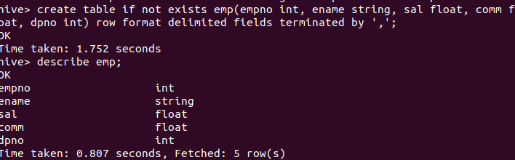

Loading data from csv:

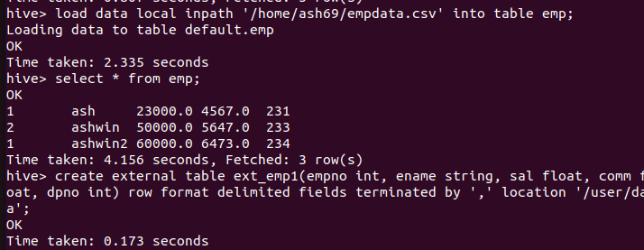

Creating External Table using hdfs Path:

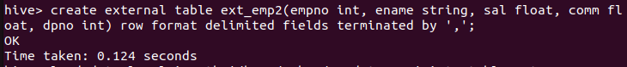

Loading the csv file to external table:



Making external table in warehouse:

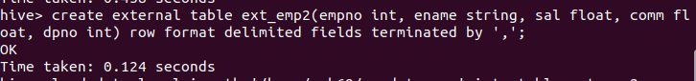

Loading csv file to second external table in warehouse

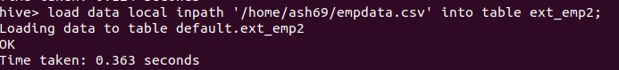

Setting Partition mode to dynamic:



Making partition table in dynamic mode:

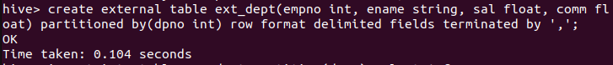

Inserting data:

